42.36: The energies corresponding to the observed wavelengths are 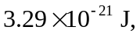
The average spacing of these energies is 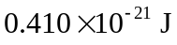 and using the result of Problem (44-4), these are seen to correspond to transition from levels 8, 7, 6, 5 and 4 to the respective next lower levels.
Then, 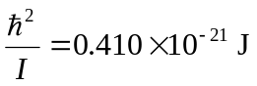, from which 